**Project Design Phase-II**

**Technology Stack (Architecture & Stack)**

|  |  |
| --- | --- |
| Date | 24 June 2025 |
| Team ID | LTVIP2025TMID49157 |
| Project Name | Cosmetic Insights : Navigating Cosmetics Trends and Consumer Insights with Tableau |
| Maximum Marks | 4 Marks |

**Technical Architecture:**

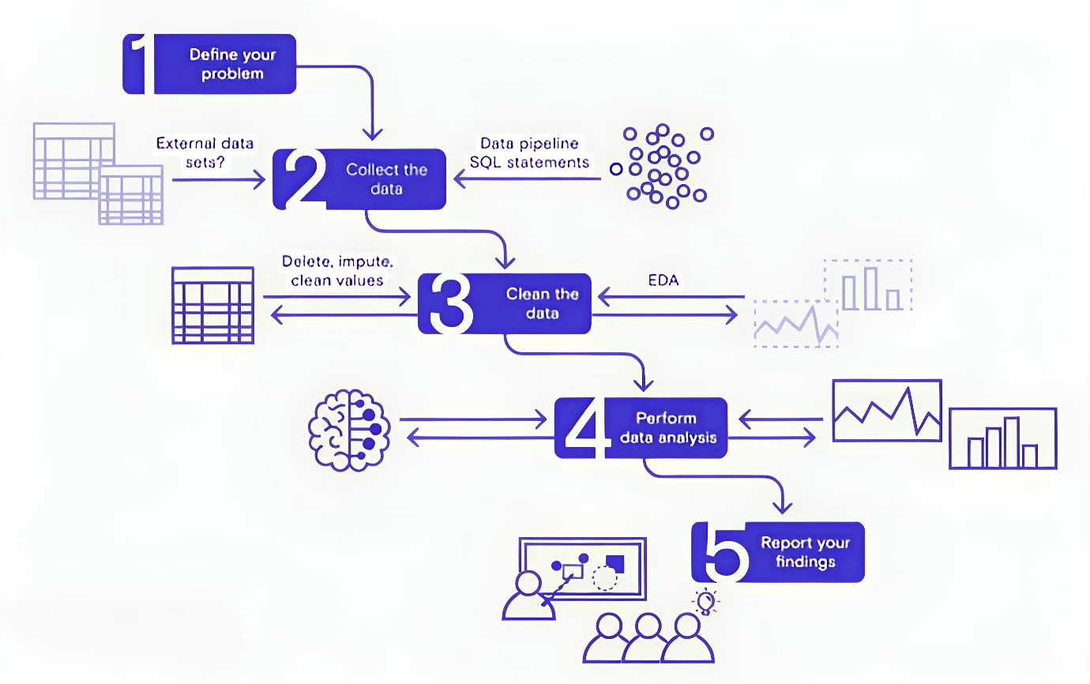

**Table-1 : Components & Technologies:**

|  |  |  |  |
| --- | --- | --- | --- |
| **S.No** | **Component** | **Description** | **Technology** |
|  | User Interface | Web interface for viewing dashboards and insights | HTML, CSS, JavaScript, Tableau Public Embedding |
|  | Data Processing Logic | Data cleaning & preprocessing scripts | Python (Pandas, NumPy) |
|  | Data Storage | Stores raw data and cleaned datasets | CSV files, Google Sheets, or simple SQL/NoSQL DB (e.g., MySQL, MongoDB) |
|  | Visualization Layer | Creates interactive visual dashboards and charts | Tableau Public / Tableau Desktop |
|  | Infrastructure (Server / Hosting) | Hosts any scripts and serves embedded dashboards | Local Machine or Cloud VM (Render, Railway, or simple shared hosting) |

**Table-2: Application Characteristics:**

| **S.No** | **Characteristics** | **Description** | **Technology** |
| --- | --- | --- | --- |
|  | Open-Source Frameworks | Uses open-source Python libraries for data processing | Python (Pandas, NumPy) |
|  | Security | Secure storage and access to Tableau dashboards with controlled sharing | Tableau permissions, secure hosting |
|  | Scalable Architecture | Justify the scalability of architecture (3 – tier, Micro-services) | Technology used |
|  | Availability | Dashboards accessible anytime via Tableau Public or Cloud link | Tableau Public, Render, Railway |
|  | Performance | Dashboards use Tableau Extracts for faster load; small datasets for demo | Tableau Data Extracts, Python ETL |